**Rural Municipality of Clyde River**

**Public Meeting**

The Rural Municipality of Clyde River invites residents and interested parties to a public meeting on **Wednesday, October 1, 2025, at 6:30 p.m. at the Riverview Community Centre**, 718 Clyde River Road, Clyde River.

The purpose of the meeting is to review and receive comments on a Mixed Use Development and Municipal Re-structuring Proposal.

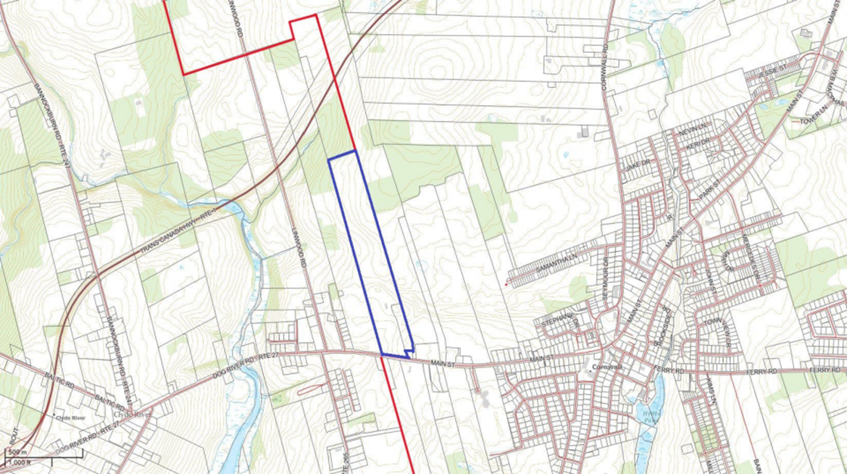

If you are unable to attend the public meeting in person, written comments can be forwarded by email to [administrator@clyderiverpei.com](mailto:administrator@clyderiverpei.com). The public can also contact the municipality by telephone at 902-675-2959.