
Newsletter—FALL 2026

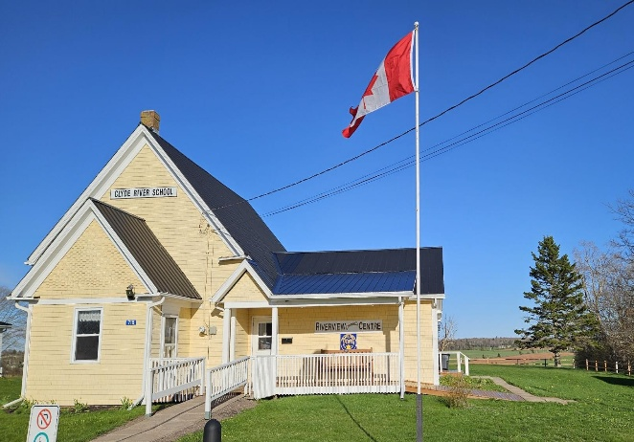
Mayor’s message
I hope everyone had a great summer and has settled into our fall/back-to-school routines. We had a fabulous turnout at our Canada Day event—was great to see familiar faces and meet new residents!

Our municipal election is around the corner—on November 2, PEI residents in municipalities across the island will go to the polls to elect their new community representatives. I strongly encourage you to consider running as candidate on the Clyde River Council! The nomination period closes on October 16—please refer to the information below.

After eight rewarding years of personal involvement as a councillor, then as mayor, I have decided to step down so I can focus on greater responsibilities during my “day job.” I have really enjoyed working with fellow residents on committees and on Council to help make Clyde River a better place, and to sustain special aspects of our community in the long term. I have greatly appreciated the professionalism, respect and willingness to volunteer of all involved.

Look into what our community has to offer this fall and winter!
-Steven Shoemaker, Mayor

Municipal Elections – November 2, 2026
The Rural Municipality of Clyde River is be having an election for Mayor and Council (six members) to serve for the next four years. Active resident participation is KEY in local governance!

Consider running for this valuable public service. Any Canadian citizen over 18 years of age who has been a resident of Clyde River for at least six months is eligible to run. The nomination period runs from October 7 to 16, 2026. All nominations must be received during this time.

You can pick up nomination forms and get more information at the election office at the Riverview Community Center, 718 Clyde River Road, Clyde River, or visit clyderiverpei.com (click the “News” tab, top of the page). Have your say…and get involved in our wonderful community!

Recreation rebate for youth
A recreation rebate of $60/activity is available for youth 18 years and under. Youth must reside in Clyde River. All types of recreation that enhance a healthy lifestyle qualify—such as sports, theatre and music. The maximum rebate per child is $120 for two activities per year, which runs from April 1 to March 31. Apply today at clyderiverpei.com (click the “Residents” tab, top of the page).

Emergency Management Organization (EMO)
We now have a municipal emergency plan to help protect the health, safety and welfare of community members in these situations. With our recent purchase of a generator, the Riverview Community Centre is now certified as a reception centre.

As part of our plan, we’re looking to identify the members in our community who may be vulnerable during an emergency, or those who could help their neighbors in these situations.
We encourage you to complete our online Emergency Management questionnaire on our website (click the “Residents” tab); or drop by Riverview Community Centre to get a copy.

Free pancake breakfasts
Put on by the Burnside Presbyterian Church, our free pancake breakfasts are usually held on the first Saturday of each month. Join us 8-10 am for great food and meet your neighbours! Keep an eye on our website for updates.

Fitness Classes at the Centre
On Monday and Thursday at 6pm, join the “The Fit Chicks of Clyde River” fitness class! To register, contact Angela Frizzell. Clyde River is pleased to offer a free Seniors’ fitness class at 9am on Saturdays. For more information on these classes, call Angela at 394-5099.

Senior Lunch and Learns this winter
Our popular Seniors Lunch and Learns, funded by the provincial Seniors’ Secretariat, will resume in January and run until March. Stay tuned for updates on our website.

+++++++++++++++++++++++++++++++++++++++++++++++++++++++++++++

To rent the Riverview Community Centre for your event:

- call Dan, Chief administrative officer, at 902-675-2959, or
- visit clyderiverpei.com and check out more Clyde River news, info, stories, history, and photos while you’re there!

Follow us on Facebook @clyderiverpei (our Instagram is in progress!)
++++++++++++++++++++++++++++++++++++++++++++++++++++

